TUMA Kare offers professional surface and flooring solutions for residential and commercial spaces. We deliver durable, modern finishes with a strong focus on quality and reliability.
Index.html
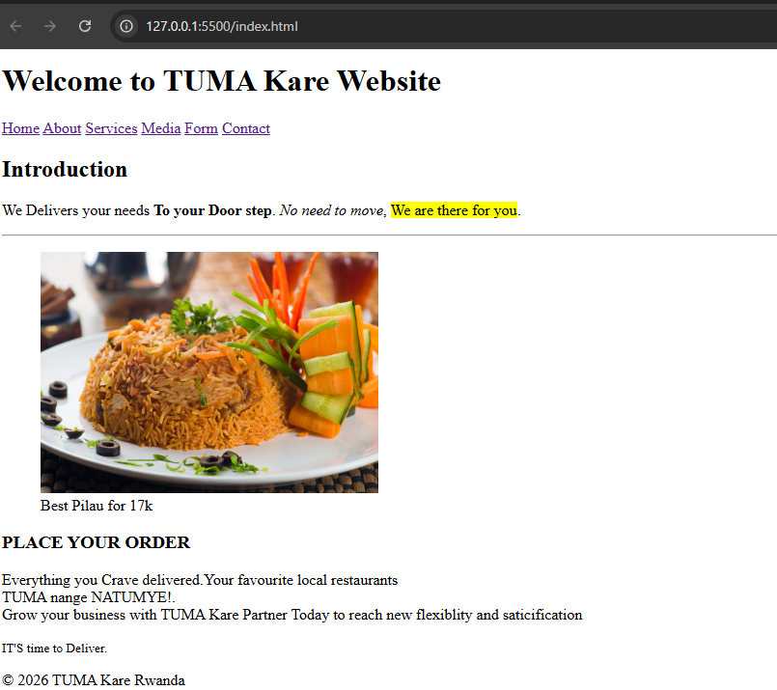

About.html
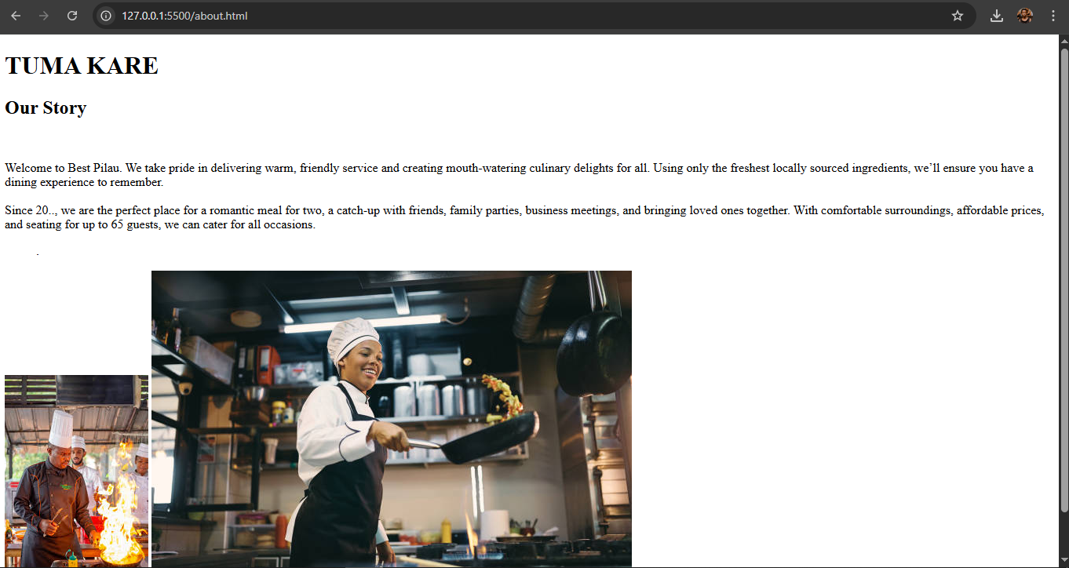

Service.html
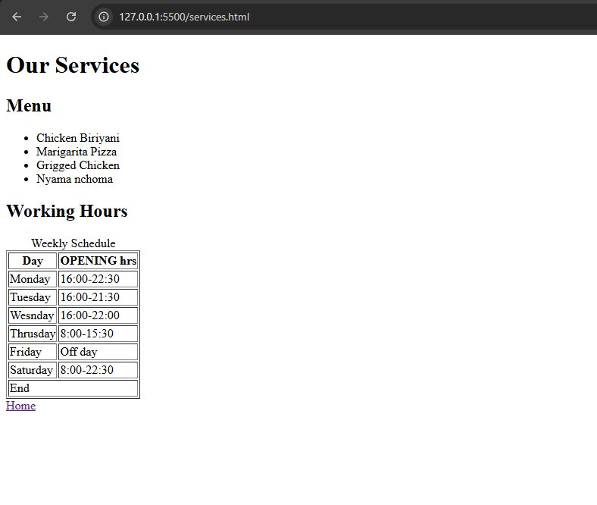

Media
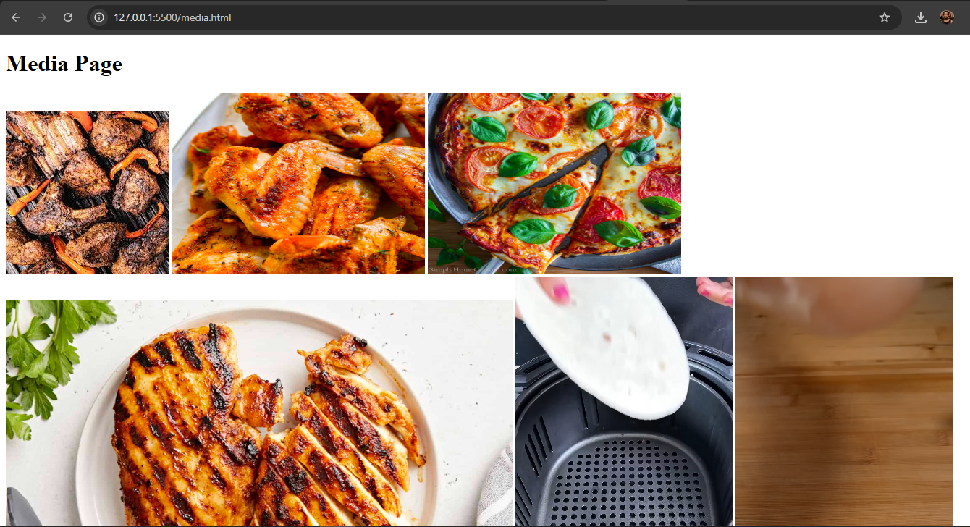
Form.html

